**Project Design Phase-II**

**Data Flow Diagram & User Stories**

|  |  |
| --- | --- |
| Date | 31 January 2025 |
| Team ID |  |
| Project Name |  |
| Maximum Marks | 4 Marks |

**Data Flow Diagrams:**

A **Data Flow Diagram (DFD)** illustrates how data moves within the **FreelanceFinder platform**. It captures user interactions (freelancers, clients, admins), internal processing (project posting, bidding, messaging, payments), and the storage of data (user profiles, messages, transaction logs).

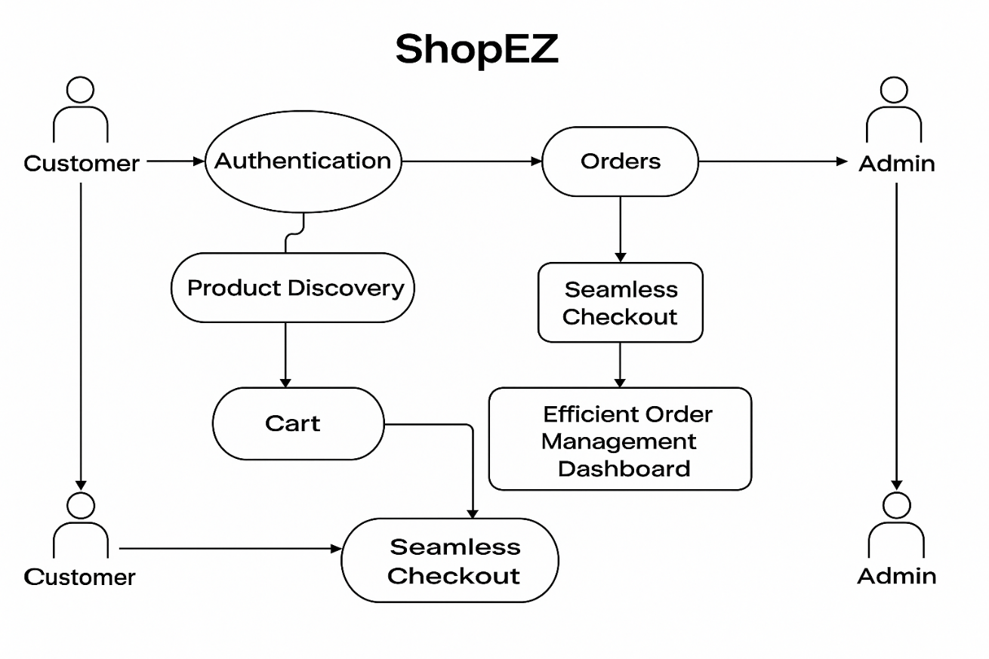

**Example:** [**(Simplified)**](https://developer.ibm.com/patterns/visualize-unstructured-text/)

**User Stories:**

Use the below template to list all the user stories for the product.

| **User Type** | **Functional Requirement (Epic)** | **User Story Number** | **User Story / Task** | **Acceptance criteria** | **Priority** | **Release** |
| --- | --- | --- | --- | --- | --- | --- |
| Customer (Mobile user) | Registration | USN-1 | As a user, I can register for the application by entering my email, password, and confirming my password. | I can access my account / dashboard | High | Sprint-1 |
| Customer |  | USN-2 | As a user, I will receive confirmation email once I have registered for the application | I can receive confirmation email & click confirm | High | Sprint-1 |
| Customer |  | USN-3 | As a user, I can register for the application through Facebook | I can register & access the dashboard with Facebook Login | Low | Sprint-2 |
| Customer |  | USN-4 | As a user, I can register for the application through Gmail | Account is created and accessible via credentials. | Medium | Sprint-1 |
| Customer | Login | USN-5 | As a user, I can log into the application by entering email & password | Account is created and accessible via credentials. | High | Sprint-1 |
| Customer | Dashboard | USN-6 |  |  |  |  |
| Customer (Web user) | Cart Management | USN-7 | As a customer, I can add or remove products from the shopping cart. | Cart updates in real time. | Medium | Sprint-2 |
| Administrator | Product Management | USN-8 | As an admin, I can add, update, or delete products. | Product catalog reflects changes instantly. | High | Sprint-2 |